LAB ASSIGNMENT-1

Components of Central Processing Unit (box)-

* **CPU Box** – It is the cabinet to hold all the non-input output Hardware, i.e. (Motherboard, RAM, etc.) so it would be safe and organized.
* **SMPS (Switched-Mode Power Supply)** – A SMPS is an electronic circuit that coverts electricity to such a lower voltage that the components inside the CPU box are not damaged, also it contains inductors or capacitors to protect against the fluctuating voltage input to the computer. The main advantage of the switching power supply is greater efficiency than linear regulators because the switching transistor dissipates little power when acting as a switch. Other advantages include smaller size and lighter weight from the elimination of heavy line-frequency transformers, and comparable heat generation. Standby power loss is often much less than transformers.
* **Motherboard** – It’s the base for all major components and circuitry of the CPU, Memory, input-output connections, etc. It is made of a rigid non-conducting material, there are some lines called traces that are made with aluminum foil, which actually are the circuits. In addition to circuits, a motherboard contains Sockets and Slots to connect other components. 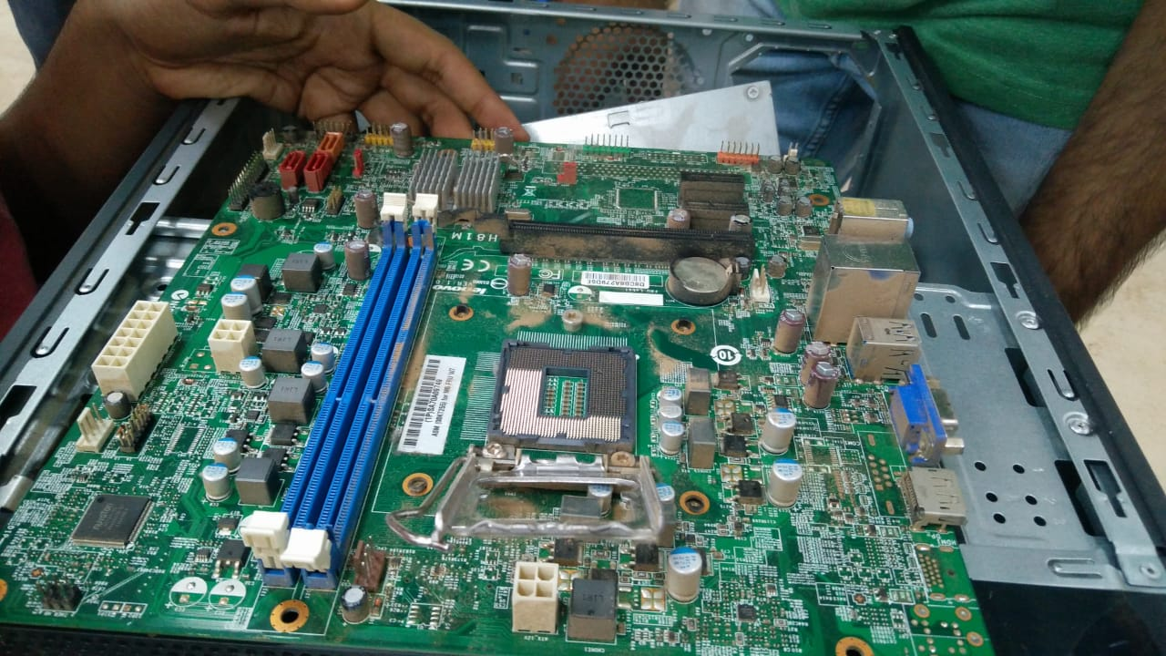
* **Heat Sink-** The heat sink is the Cooling component of The Processor, it has sheet like structures, mainly to increase surface area for easy dissipation of heat, and a fan is also connected to the top of heat sink as to speed up the cooling process. The Heat Sink is connected by a coolant material with the processor
* **RAM (Random Access Memory)** -RAM is a form of computer data storage that stores data and machine code currently being used. A random-access memory device allows data items to be read or written in almost the same amount of time irrespective of the physical location of data inside the memory. This volatile memory is used to load up the OS and all the tasks and application while using the Computer.

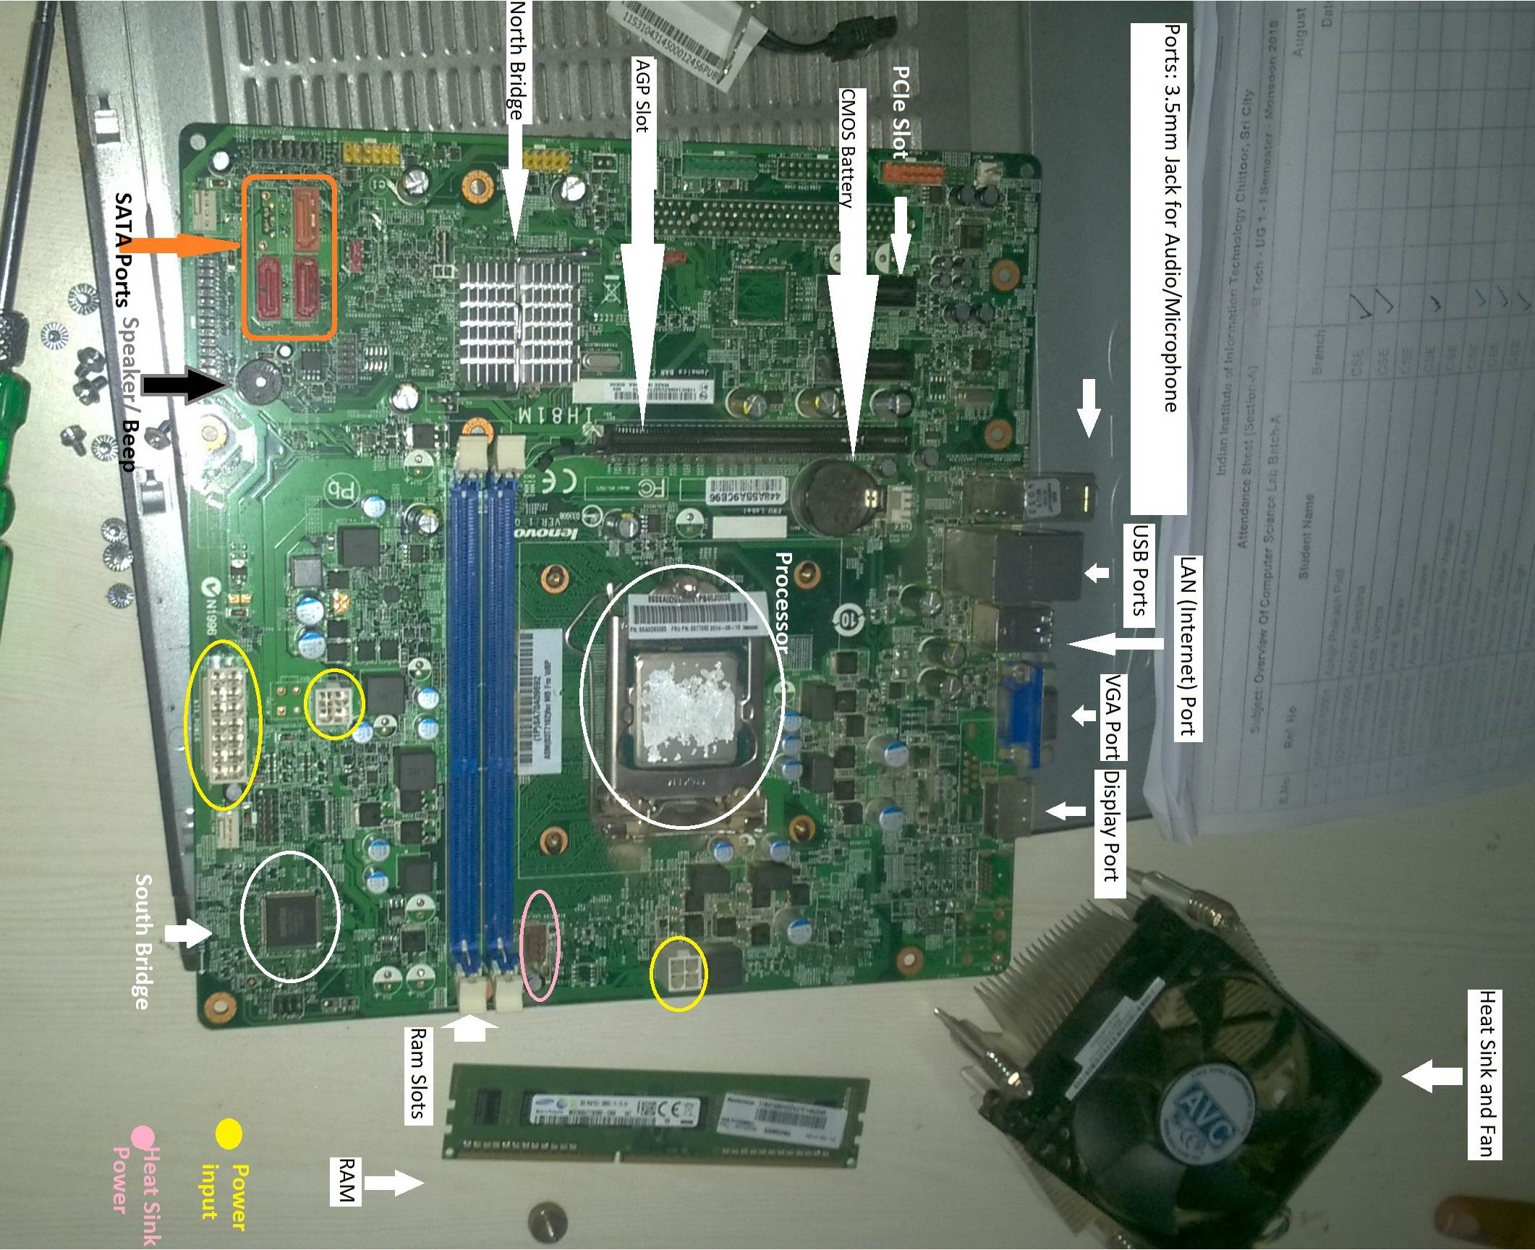

* 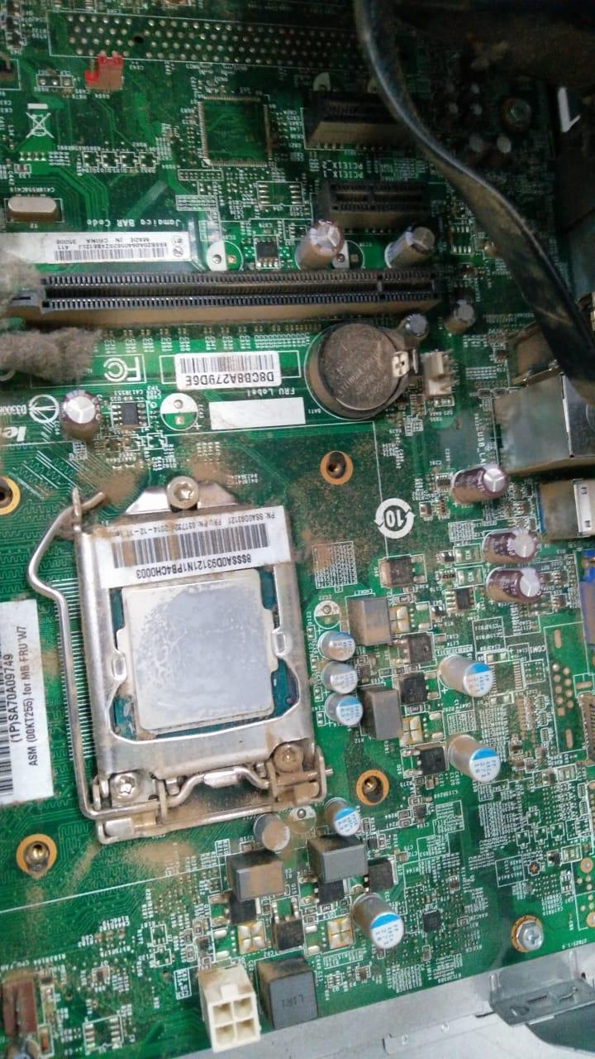**CMOS Battery-** It is used to power the CMOS (Complementary Metal-Oxide Semiconductor) and used to store information such as Date & Time and sometimes system hardware settings. The CMOS battery (real-time clock (RTC), clock battery) is generally a CR2032 lithium coin cell. This cell battery has an estimated life of 3 years when power supply unit (PSU) or SMPS is unplugged. This battery is not rechargeable. Motherboards have circuitry preventing batteries from being charged and discharged when a motherboard is powered on.
* **PORTS**

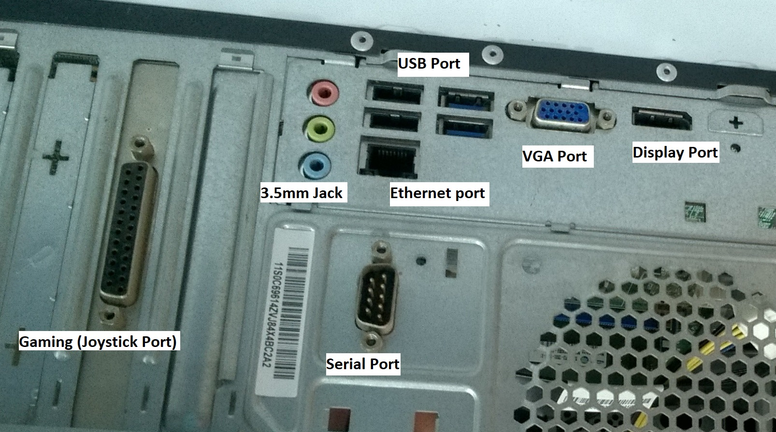

1. 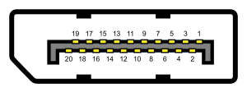**Display Port**- It is used to connect Audio, Video etc. to External Monitor. Display Port (DP) is a digital display interface developed by a consortium of PC and chip manufacturers and standardized by the Video Electronics Standards Association (VESA). The interface is primarily used to connect a video source to a display device such as a computer monitor. Display Port was designed to replace VGA, DVI, and FPD-Link. The interface is backward compatible with other interfaces, such as HDMI and DVI, through the use of either active or passive adapters.

Image from Wikipedia

1. VGA (Visual Graphics Array) Port- It is used for standard video output. A Video Graphics Array (VGA) connector is a three-row 15-pin DE-15 connector. The 15-pin VGA connector was provided on many video cards, computer monitors, laptop computers, projectors, and high definition television sets. On laptop computers or other small devices, a mini-VGA port was sometimes used in place of the full-sized VGA connector.

Image from Wikipedia

[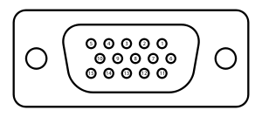](https://en.wikipedia.org/wiki/File:DE15_Connector_Pinout.svg)[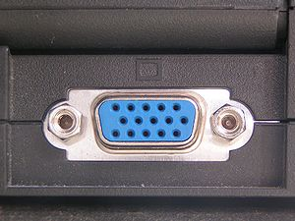](https://en.wikipedia.org/wiki/File:SVGA_port.jpg)

1. LAN (Ethernet) Port- It is used to connect your computer to a High speed LAN connection. Ethernet use twisted pair and fiber optic links in conjunction with switches. The Ethernet standards comprise several wiring and signaling variants of the OSI physical layer in use with Ethernet.

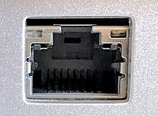

Image from Wikipedia

1. USB (Universal Serial Bus) Port- This is the most commonly used port to connect to wide range of Devices. USB (abbreviation of Universal Serial Bus) is an [industry standard](https://en.wikipedia.org/wiki/Technical_standard) that establishes specifications for cables, connectors and [protocols](https://en.wikipedia.org/wiki/Communications_protocol) for [connection, communication and power supply](https://en.wikipedia.org/wiki/Computer_interface) between personal computers and their peripheral devices.

USB Type-A receptacle.svg 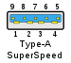 USB Mini-B receptacle.svg USB Micro-B receptacle.svg Connector USB 3 IMGP6017 wp.jpg USB-Type-C.svg

Image from Wikipedia

1. 3.5mm Jacks- These contains audio input, audio output and line-in ports used to communicate through voice.

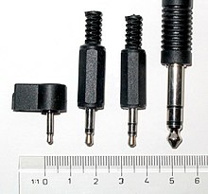

Image from Wikipedia

1. **SATA (Serial Advanced Technology Attachment) Ports-** SATA is a computer bus interface that connects host bus adapters to mass storage devices such as Hard Disk drives, optical drives, and solid-state drives. Serial ATA succeeded the older Parallel ATA standard, offering several advantages over the older interface: reduced cable size and cost.

https://upload.wikimedia.org/wikipedia/commons/thumb/7/7c/SATA_Ports.jpg/250px-SATA_Ports.jpg 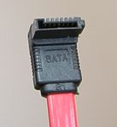 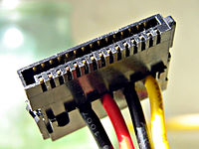

* **SLOTS**

1. **RAM Slot-** This is used to connect RAM to the motherboard.

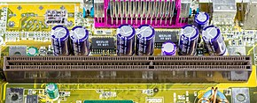

Image from Wikipedia

1. **AGP (Accelerated Graphic Port) Slot**- It is used to connect your Graphic Card to your Motherboard. The Accelerated Graphics Port (AGP) was designed as a high-speed point-to-point channel for attaching a video card to a computer system, primarily to assist in the acceleration of 3D computer graphics. It was originally designed as a successor to PCI-type connections for video cards. Since 2004, AGP has been progressively phased out in favor of PCI Express (PCI-e); by mid-2008, PCI Express cards dominated the market and only a few AGP models were available, with GPU manufacturers and add-in board partners eventually dropping support for the interface in favor of PCI Express.

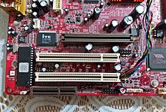

Image from Wikipedia

1. **PCI-e (Peripheral Components Interconnect) Slots**- These are Expansion Slots to connect different type of components, (PCI based) to increase or add new functionality. PCI-e is a high-speed serial computer expansion bus standard, designed to replace the older PCI, PCI-X and AGP bus standards. PCI-e has numerous improvements over the older standards, including higher maximum system bus throughput, lower I/O pin count and smaller physical footprint, better performance scaling for bus devices, a more detailed error detection and reporting mechanism.

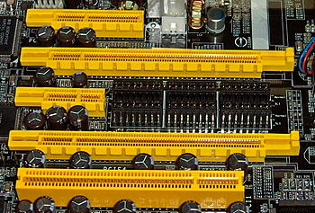

PCI Express ×4

PCI Express ×16

PCI Express ×1

PCI Express ×16

Conventional PCI (32bit-5V)

* **Northbridge**- It is Integrated Chip whose major function is to facilitate the transfer of data from RAM to the Processor and vice versa. A Northbridge or host bridge is one of the two chips in the core logic chipset architecture on a PC motherboard, the other being the Southbridge. Unlike the Southbridge, Northbridge is connected directly to the CPU via the front-side bus (FSB) and is thus responsible for tasks that require the highest performance. The Northbridge is usually paired with a Southbridge, also known as I/O controller hub. In systems where they are included, these two chips manage communications between the CPU and other parts of the motherboard, and constitute the core logic chipset of the PC motherboard
* **Southbridge**- A Southbridge chipset handles all of a computer's I/O functions, such as USB, audio, serial, the system BIOS, the ISA bus, the interrupt controller and the IDE channels. i.e., it takes care of input output and storage connections.
* **Power Input**- This is the slot where the power is given to the motherboard through SMPS.

*The labelled picture of motherboard and Slots is on the next Page*